Project Design Phase-II

Data Flow Diagram & User Stories

|  |  |
| --- | --- |
| Date | 18 October 2022 |
| Team ID | PNT2022TMID31222 |
| Project Name | Classification Of Arrhythmia By Using Deep Learning With 2- D ECG Spectral Image Representation |
| Maximum Marks | 4 Marks |

# Data Flow Diagrams:

A Data Flow Diagram (DFD) is a traditional visual representation of the information flows within a system. A neat and clear DFD can depict the right amount of the system requirement graphically. It shows how data enters and leaves the system, what changes the information, and where data is stored.

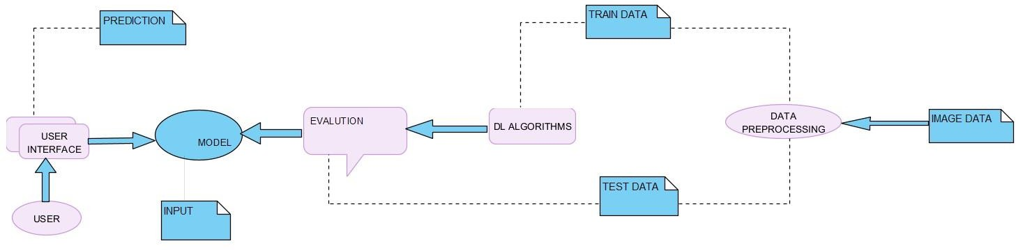

# USE CASE

Use the below template to list all the user stories for the product.

|  |  |  |  |  |  |  |
| --- | --- | --- | --- | --- | --- | --- |
| **User Type** | **Functional**  **Requirement (Epic)** | **User Story Number** | **User Story / Task** | **Acceptance criteria** | **Priority** | **Release** |
| Customer (Mobile user) | Registration | USN-1 | As a user, I can register for the application by entering my email, password, and confirming  My password. | I can access my account / dashboard | High | Sprint-1 |
|  |  | USN-2 | As a user, I can register for the application  using Gmail | I can access my  account/dashboard | High | Sprint-1 |
|  | Confirmation | USN-3 | As a user, I will receive confirmation email  once I have registered for the application | I can receive confirmation  email & click confirm | High | Sprint-1 |
| Data Input | Getting user input | USN-4 | As a user, I can share my input like the  medical reports to the application | I can proceed with further  steps with no error | High | Sprint-2 |
|  | Save report | USN-5 | The data that is provided by the user will be  saved in the application backend for future purpose | If all the data is in correct format it will be stored | High | Sprint-2 |
| Customer Interaction | Chat with doctor | USN-6 | If the customer is interested he can consult with the doctor regarding doubts | If the doctor is free the appointment will be  accepted | Low | Sprint-1 |
| Report Generation | Get complete report | USN-7 | After the complete analysis the report will be generated | The results will be shown  on the screen to the patients | High | Sprint-2 |